Registration Information

Registration will be held at the Mariner’s Centre in August 25, 27, and Sept. 1, 3 from 5:30 – 7pm

Refund Policy

There will be no refunds without
a medical certificate verifying illness or injury. There is also be a $50.00 administration fee if a skater withdraws after acceptance to YSC.

NSF cheques will be charged an additional $20.00 fee.

YSC reserves the right to cancel or change any skating session due to lack of registration.

- Please note: All fees are non-refundable

Kidsport

Funds are available to help with the ever increasing costs of sports programs for children. For more information please visit www.kidsport.ca

Yamouth Skating Club

Mailing address:
YSC
PO Box 571
Yarmouth, Nova Scotia
B5A 4B4
Club email: yarmouthskatingclub@hotmail.ca

2015-2016 Club Executive
President Cheryl Cook (Temporary)
Vice President Ginette Theriault
Past President
Secretary Jamie Spates
Treasurer Cheryl Cook
Test Chair Treena Landry
Publicity Treena Landry
Registrar Marilee Lyons
Members at Large Denise Stone, Herb Stiene
Vicki d'Entremont

Professional Coaching Staff
Megan Long
meganplong@gmail.com

Lorraine Swim
lorraineswim@hotmail.com

- Sometimes the Mariner’s Centre may
need to change our ice times. In the event
that this occurs we will post any changes
on the website and if we have your email address we can email it to you as well.
Please make sure we have a valid email address and that you check it and the website regularly

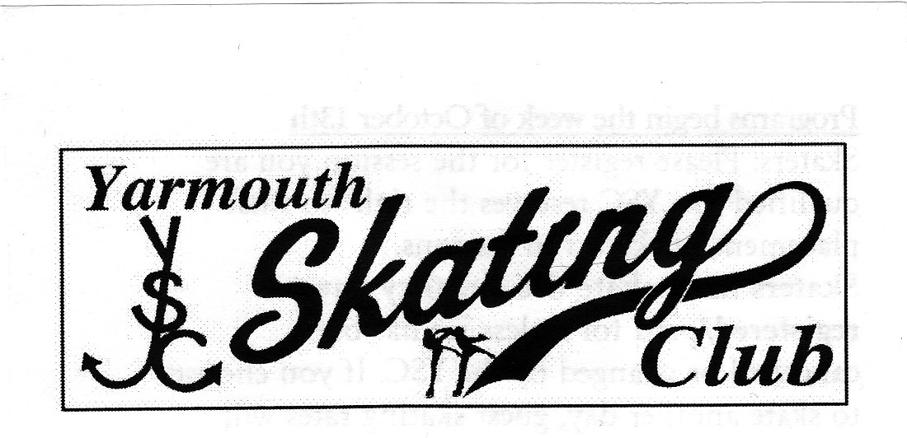

Presents

FALL SCHOOL

2015

September 8 - October 8

Director of Programming
Megan Long

www.yarmouthskatingclub.com

